# Appendix B.13.7 Infection Control Plan

## Safety and Control Measures

Controlling exposures to occupational hazards is the fundamental method of protecting workers. Traditionally, a hierarchy of controls has been used as a means of determining how to implement feasible and effective control solutions.

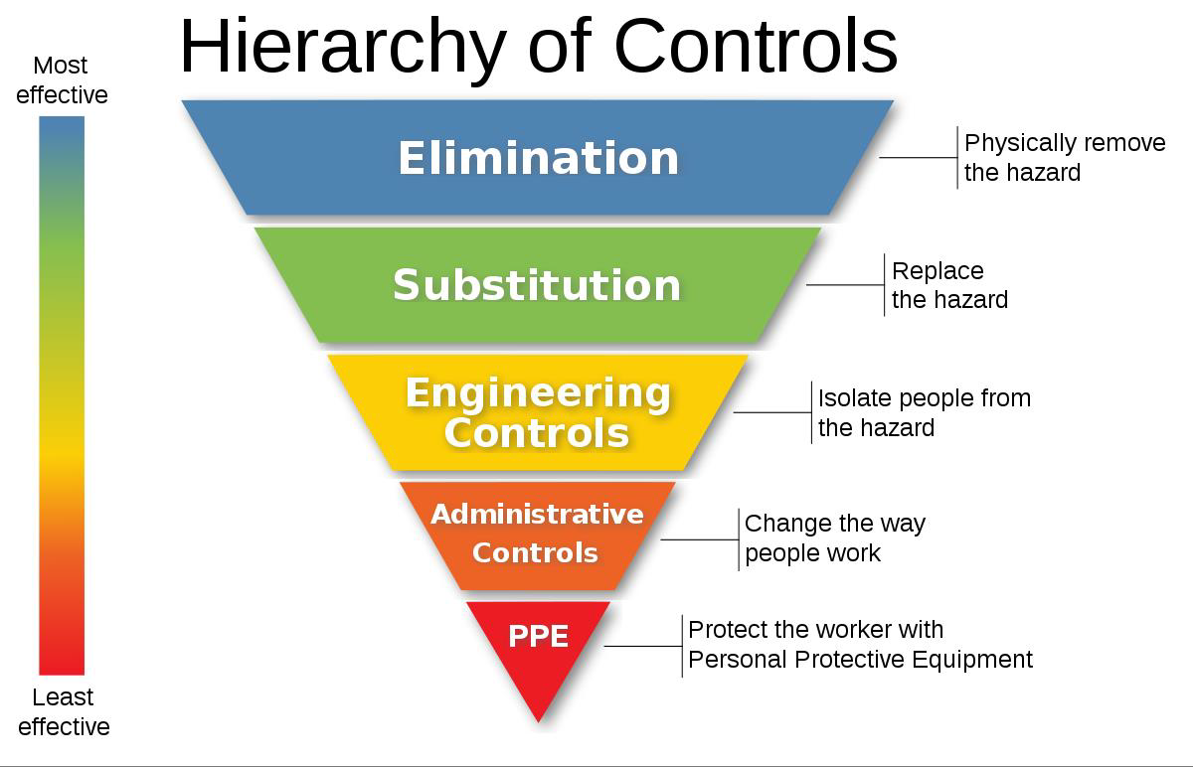

Source: [*https://www.cdc.gov/niosh/topics/hierarchy/default.html*](https://www.cdc.gov/niosh/topics/hierarchy/default.html)

Standard precautions include a group of infection prevention practices that apply to all patients, regardless of suspected or confirmed infection status, in any setting in which healthcare is delivered.

Standard precautions include:

* Hand hygiene
* PPE use
* Safe injection practices
* Safe handling/cleaning of equipment and environmental surfaces
* Respiratory hygiene and cough etiquette

Administrative controls:

* Workplace safety programs
* Vaccination of healthcare personnel
* Infection control and prevention protocols
* Plans, procedures, algorithms, checklists

For health care, the appropriate PPE is determined by the role of the individual; either first responder or first receiver.

### First Responders

First responders are responsible for protecting and preserving:

* Life (e.g., paramedics, emergency medical technicians, ambulance service personnel)
* Property (e.g., firefighters)
* Evidence (e.g., law enforcement)
* Environment (e.g., HAZMAT teams)

First responder activities generally occur at the site of an incident. First responders must have access to PPE that provides the highest levels of skin and respiratory protection.