Appendix B.13.6 HCC HMAC Coordination

Job Aids/Position Descriptions

Table of Contents
Coalition Activation, Response, Demobilization Checklists 1
RHPC HMAC Activation Checklist 2
HMAC Activation Checklist by Discipline 3
HMAC Activation Request by Hospital, LTC, other Healthcare 4
HMAC Activation Request by EMS 5
HMAC Activation Request by Public Health 5
HMAC Activation Request by Emergency Manager 7
HMAC Activation Request by other Coalition Member or Regional Partner 8
RHPC On-Call Staff: Operational Checklist 9
HICS Forms Table: 11
The Operational Planning P 12
Job Action Sheets for HMAC Roles 13
Briefings Guide 26
ICS Smart Objectives 27

Coalition Activation, Response, Demobilization Checklists
The Central Region Health Care Preparedness Coordinator (RHPC) will consider activation of the coalition HMAC when contacted with a request from a coalition member to provide support. The following pages provide checklists that identify specific notification, activation, and coordination action considerations for the primary coalition member participants. Please note, respective disciplines should utilize existing methods of information sharing amongst their disciplines and jurisdictions as outlined in their local or agency/organization plans.
When the HMAC is activated – the coalition will follow Incident Command. Contained within this Appendix are the basic ICS documents which include the Planning B, ICS forms, and Briefing Guidelines.

RHPC HMAC Activation Checklist
Activation | Check
Notify all HMAC Coordinating group members of incident
Confirm receipt of information to HMAC members
Contact MDH Consultant Supervisors (PHEP, HPP respectively)
If supervisors are not available call MDH EPR 1-651-201-5735
Create Coordination Center Room on MNTrac
Invite Coordination Entity + MDH Supervisor of HSPP and PHEP to Coordination Center Room
Identify additional resource members necessary for response
Invite resource members to Coordination Center Room
Begin incident check-in list (ICS Form 211)
Begin individual activity logs (ICS Form 214)
Response | Check
Establish response structure/roles (ICS Form 203)
Identify response objectives (ICS Form 202); including demobilization trigger
Establish communication plan (ICS Form 204 & 205)
Complete incident briefing (ICS Form 201)
Determine incident briefing schedule
Share incident briefing schedule with appropriate partners
Share incident briefing with appropriate partners as pre-determined intervals
Repeat as necessary for duration of incident
Re-evaluate demobilization readiness
Demobilization | Check
Choose closing date/time for operations
Complete demobilization checkout (ICS Form 221)
Provide final incident briefing indicating close date/time to partners
Close Coordination Center Room on MNTrac
Finalize and submit all ICS Forms
Conduct on-site/virtual debriefing
Set date for After Action Meeting
Review supplies/resources
Replenish supplies as necessary

HMAC Activation Checklist by Discipline

HMAC: RHPC Response
HMAC Activation – RHPC Actions | Check
Coalition member contacts RHPC who collects initial information:
Person calling
Agency/Facility
Incident location
Incident type
Brief Description
Point of contact
Support needed
Supplies, Assets, information sharing
Use MNTrac to notify all coalition members of the incident and need for activation of HMAC
Create coordination center room in MNTrac
Invite HMAC group and MDH EPR Supervisor to coordination center room
Identify and invite additional SME’s and resource members necessary for response
Complete and distribute incident briefing (ICS form 201)
HMAC Member Actions | Check
Provide the following information to participants in the coordination center room:
Current situation (discipline perspective) whether actively involved or monitoring
Current external (community) situation
Are other partner disciplines activated, EMS-MACC, Strike team, etc.
Anticipated or actual support needs (supplies, equipment, personnel, facility support)
Agency point of contact (name) and contact information and backup contact to allow for follow up

HMAC Activation Request by Hospital, LTC, other Healthcare
Coalition Member Activation of HMAC | Check
Prior to contacting the RHPC to discuss support activities, identify the following:
Person calling:
Agency/Facility:
Incident location:
Incident type:
Designated point of contact:
Support needed (supplies, assets, information sharing, etc.)
Contact the WCMHPC RHPC 24/7 320-654-2720 and provide the following information:
“This is [Your facility/organization name] requesting RHPC or HMAC assistance”
Your callback information if calling by phone and backup notification method
HMAC Member Actions | Check
Provide the following information to participants in the coordination center room:
Current situation (discipline perspective) whether actively involved or monitoring
Current external (community) situation
Are other partner disciplines activated, EMS-MACC, Strike team, etc.
Anticipated or actual support needs (supplies, equipment, personnel, facility support)
Agency point of contact (name) and contact information to allow for follow up
Continue providing discipline informational updates and essential information as requested

HMAC Activation Request by EMS
Coalition Member Activation of HMAC | Check
Prior to contacting the RHPC to discuss support activities, identify the following:
Person calling:
Agency/Facility:
Incident location:
Incident type:
Designated point of contact:
Support needed:
Supplies, Assets, information sharing, etc.
Contact the RHPC 24/7 at 320-654-2720 and provide the following information:
“This is [Your facility/organization name] requesting RHPC or HMAC assistance”
Your callback information if calling by phone and backup notification method
Expected RHPC Actions | Check
The RHPC actions may include:
Notify all coalition members of the incident and activation of HMAC
Confirm information received to HMAC
Create coordination center room in MNTrac
Invite HMAC and MDH EPR Supervisor to coordination center room
Identify and invite additional SME’s and resource members necessary for response
Complete and distribute incident briefing (ICS form 201)
HMAC Member Actions | Check
Provide the following information to participants in the coordination center room:
Current situation (discipline perspective) whether actively involved or monitoring
Current external (community) situation
Are other partner disciplines activated, EMS-MACC, Strike team, etc.
Anticipated or actual support needs (supplies, equipment, personnel, facility support)
Agency point of contact (name) and contact information to allow for follow up
Continue providing discipline informational updates and essential information as requested

HMAC Activation Request by Public Health
Coalition Member Activation of HMAC | Check
Prior to contacting the RHPC to discuss support activities, identify the following:
Incident location
Incident type
Designated point of contact
What support you need (examples):
Supply equipment support
Information sharing support
Monitoring
Contact the Central Region RHPC 24/7 at 320-654-2720 and provide the following information:
“This is [Your agency name] requesting RHPC or HMAC assistance”
Your callback information if calling by phone and backup notification method
HMAC Member Actions | Check
Provide the following information to participants in the coordination center room:
Current situation (discipline perspective) whether actively involved or monitoring
Current external (community) situation
Anticipated or actual support needs (supplies, equipment, personnel, facility support)
Agency point of contact (name) and contact information to allow for follow up

HMAC Activation Request by Emergency Manager
Coalition Member Activation of HMAC | Check
Prior to contacting the RHPC to discuss support activities, identify the following:
Person calling:
Agency/Facility:
Incident location:
Incident type:
Designated point of contact:
Support available or needed:
Supplies, Assets, information sharing, etc.
Contact the RHPC 24/7 at 320-654-2720 and provide the following information:
“This is [Your county/city name] providing/requesting RHPC or HMAC assistance”
Your callback information if calling by phone and backup notification method
HMAC Member Actions | Check
Provide the following information to participants in the coordination center room:
Current situation (discipline perspective) whether actively involved or monitoring
Current external (community) situation
Are other partner disciplines activated, EMS-MACC, Strike team, etc.
Anticipated or actual support needs (supplies, equipment, personnel, facility support)
Agency point of contact (name) and contact information to allow for follow up
Continue providing discipline informational updates and essential information as requested

HMAC Activation Request by other Coalition Member or Regional Partner
Coalition Member Activation of HMAC | Check
Prior to contacting the RHPC to discuss support activities identify the following:
Incident location
Incident type
Designated point of contact
What support you need (supply, equipment, support, information sharing support, monitoring)
Contact the RHPC 24/7 at 320-654-2720 and provide the following information:
“This is [Your organization name] requesting RHPC or HMAC assistance”
Your callback information if calling by phone and backup notification method
HMAC Member Actions | Check
Provide the following information to participants in the coordination center room:
Current situation (discipline perspective) whether actively involved or monitoring
Current external (community) situation
Anticipated or actual support needs (supplies, equipment, personnel, facility support)
Agency point of contact (name) and contact information to allow for follow up

RHPC On-Call Staff: Operational Checklist
The RHPC on-call is a 24/7 staffed position that serves as an initial point of contact for the Coalition. The major responsibility of this individual is to assist with the identification of an incident for the CMHPC participants and to assist with initial notifications.
Purpose: Provide guidance for addressing the responsibilities of the RHPC On-Call staff during day to day activities and during initial response to an incident.
RHPC Responsibilities: | Check
Remain available with communication devices on a 24/7 basis while on call.
Receive initial notification of potential incident parameters and document findings on Form 201 if appropriate
Gather additional information if needed on incident parameters (refer to communications annex for numbers):
- EMS through the EMS MACC
- Local Public health or MDH
- Healthcare facilities
- Primarily affected facility(s)
- Other organizations as needed
Assess incident parameters for potential impact of one or more coalition members to:
- Safety of personnel, patients, residents at the facility(s)
- Continuity of operations for the facility(s)
- Potential for surge operations at the facility(s)
- Requirement for support (information or resources) at the facility(s)
- Make determination if this is an incident for a coalition response based upon the above parameters.
Activate the HMAC, if necessary, utilizing MNTrac, email, or other communication platform as appropriate.
Send notification to all coalition participants (MNTrac, WebEx, Email, or other platforms as appropriate)
- Include brief description and notification category in message title
- Include brief description of incident parameters as known.
- Include desired response from recipients (participate in conf call, update bed availability, etc.)
- Provide information on next expected update if known.
Note: Almost all initial notifications should be accompanied by a request for coalition members to provide a designated POC for MNTrac and to update their situation and resource status in MNTrac as appropriate.
The RHPC on-call personnel should consider carrying at all times, hard copies of the following forms for rapid access:
- Form 201
- HMAC member phone numbers
- MNTrac Alert template
- Situation Update Teleconference Template
- Communications Plan or contact list
- Coalition Response Plan

HICS Forms Table:
ICS Form | Title: | Purpose:
 | The Planning P | The Planning Process
 | IAP Quick Start Guide | IAP Quick Start Guide
 | HICS Forms | HICS Forms
HICS 201 | Incident Briefing | Provides establishment of current ICS organization; map of area affected; resources identified, ordered and assigned, and summary of current actions. Also included in the IAP Quick Start guide.  HICS 201
HICS 202 | Incident Objectives | Provides establishment of incident objectives for operational period. Also included in the IAP Quick Start guide.  HICS 202
HICS 203 | Organization Assignment List | Provides establishment of staff assigned to various positions within the ICS for the incident. Also included in the IAP Quick Start guide.  HICS 203
HICS 205 | Communication Plan | Provides information on all radio frequency or trunked radio system talk group assignments for each operational period.  HICS 205A
HICS 213 | General Message | Provides a standard template to be used for communication between ICS staff at various locations.  HICS 213
HICS 214 | Activity Log | Provides a record of personnel roster and activities undertaken during the operational period.  HICS 214
HICS 221 | Demobilization Checkout | Provides an official record of section and unit personnel demobilized.  HICS 221

The Operational Planning P

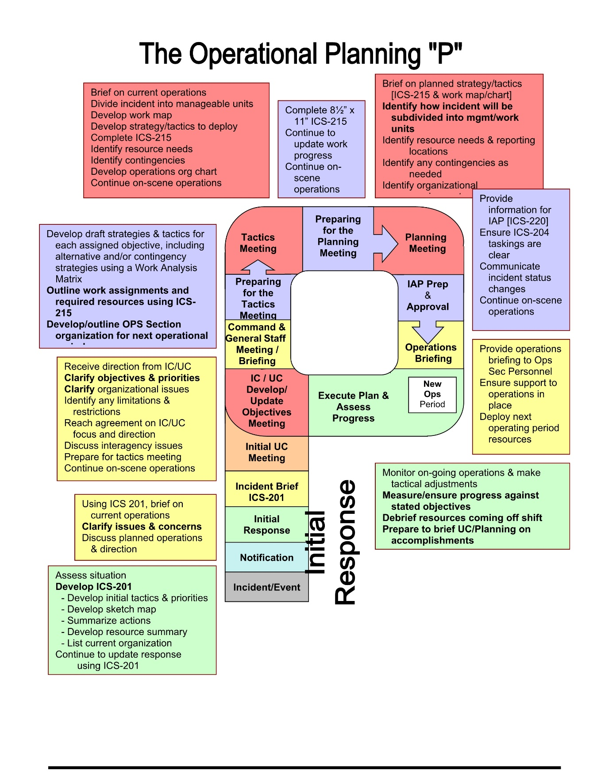

Job Action Sheets for HMAC Roles

HMAC Manager Job Action Sheet

Responsibilities:
- Coordination of agencies within the HMAC to ensure that all other HMAC representatives are provided with situation and resource status information from each discipline’s prospective.
- Coordinate and identify future health-related resource requirements.
- Coordinate and resolve differing health-related policy issues that may exist between agencies or facilities within a region or between regions.
- Work within unified command to provide strategic coordination of health-related resources.
- Coordinate with hospital staff and MN Responds volunteers (jointly with unified command).
- Coordinate and support Minnesota Mobile Medical Teams (MMMT).
- Communication with local, regional and state agencies as to the overall operations of the region.

Position Assigned to: | Date: / / | Start: ____:____ hrs.
Signature: | Initials: | End: ____:____ hrs.

Position Contact Information: Phone: Radio Channel:

Activation Phase (0-2 hours) | Time | Initial
Determine appropriate level of HMAC activation based on the situation as known
Assess available healthcare assets/obtain hospital Essential Elements of Information and the impact to public health in the community.
Determine if the HMAC is to be virtual or require a specific site location.
- Send MNTrac alert with conference call info and/or MNTrac coordination room.
- If in person is needed:
  - Send MNTrac alert with the location of the HMAC.
  - Ensure that telephone, internet and/or radio communications with EOC’s, other HMAC’s, MDH, hospitals, clinics, EMS and other partners is established and functioning.
Notify MDH and all partners (county EOC, LPH, hospitals, clinics, EMS, Red Cross, etc.) that a HMAC is being activated and for what event. This can be done via email, MNTrac alert or telephone.
Determine staffing requirements and
- Mobilize appropriate personnel.
- Establish check-in procedure.
- Fill in and post HMAC organization chart.
Schedule the initial briefing and a briefing schedule.
Briefing agenda:
- Situation Report
- Health & Medical Status
  - Current needs – patient, staff, stuff
  - Barriers, and EEIs; should at least include affected organization status)
  - Public health impacts to affected communities
- Other Coalition Member/Partner Status (as applicable)
- Public Information Status
- Safety & Security Status
- Logistics Status
- Personnel Status
- Identify Operational Concerns
- Q&A
- Next Brief: ___________________

Operational Phase (2-12 hours) | Time | Initial
Monitor general activities to ensure that all appropriate actions are being taken
Maintain situational awareness of healthcare status
Maintain situational awareness of public health impact on affected communities.
Assess and coordinate available supplies and resources. Facilitate deployment of regional cache if needed.
Conduct periodic briefings to ensure strategic objectives are current and appropriate
Support common operating picture by providing healthcare system situation/status, bed availability, and patient tracking status to hospitals, local Emergency Operations Center(s) and MDH as appropriate
Brief your relief at shift change, ensuring that ongoing activities are identified and follow-up requirements are known
Ensure that all required documentation is complete

Demobilization Phase | Time | Initial
All agencies previously notified of the opening of the WCHMAC, will be notified of the WCHMAC closure.
The WCHMAC Logs, sign-in roster and other materials are collected.
Advise County EOC’s, MDH and other community partners that WCHMAC is being deactivated.
Equipment is cleaned and returned to appropriate storage area.
Facilitate a debriefing/hotwash to gather information for the AAR/IP

Liaison Officer Job Action Sheet

Responsibility:
- Function as the incident contact person in the HMAC for representatives from other agencies.
Position Assigned to: | Date: / / | Start: ____:____ hrs.
Signature: | Initials: | End: ____:____ hrs.

Position Contact Information: Phone: Radio Channel:

Activation Phase (0-2 hours) | Time | Initial
Receive appointment and briefing from the HMAC Manager.
Read this entire Job Action Sheet and review incident management response chart (HICS Form 207). Put on position identification.
Establish contact with local, county and/or state emergency organization agencies to ascertain current status, appropriate contacts and message routing.
Communicate information obtained and coordinate with Information Officer.
Establish communication with other hospitals, local Emergency Operations Center (EOC), and/or local response agencies (e.g., public health).
Document all key activities, actions, and decisions in an Operational Log (HICS Form 214) on a continual basis.
Document all communications (internal and external) on an Incident Message Form (HICS Form 213).

Operational Phase (2-12 hours) | Time | Initial
Attend all command briefings and Incident Action Planning meetings to gather and share incident and hospital/facility information. Contribute inter-hospital information and community response activities and provide Liaison goals to the Incident Action Plan.
Request assistance and information as needed through the inter-hospital emergency communication network or from the local and/or regional EOC.
Communicate with Logistics Section Chief on status of supplies, equipment and other resources that could be mobilized to other facilities, if needed or requested.

Demobilization Phase | Time | Initial
Upon deactivation of your position, brief the HMAC Manager on current problems, outstanding issues, and follow-up requirements.
Upon deactivation of your position, submit Operational Logs (HICS Form 214) and all completed documentation to the Planning Section Chief.
Participate in after-action debriefings and document observations and recommendations for improvements for possible inclusion in the After-Action Report. Topics include:
- Accomplishments and issues
- Review of pertinent position descriptions and operational checklists
- Recommendations for procedure changes

Information Officer Job Action Sheet

Responsibilities:
- Serve as the conduit for information to and from external partners.
- Work with the Incoming Communications Monitor to disseminate information to the appropriate department or individual.
- The HMAC Information Officer does not create messages or communicate with the media. That is the responsibility of the affected agencies.
Position Assigned to: | Date: / / | Start: ____:____ hrs.
Signature: | Initials: | End: ____:____ hrs.

Position Contact Information: Phone: Radio Channel:

Activation Phase (0-2 hours) | Time | Initial
Receive appointment and briefing from the HMAC Manager
Read this entire Job Action Sheet and review incident management team chart (HICS Form 207).
Attend all command briefings and incident action planning meetings to gather and share incident and hospital information.
Coordinate the roles and responsibilities of the Incoming Communications Monitor.
Document all key activities, actions, and decisions in an Operational Log (HICS Form 214) on a continual basis.
Document all communications (internal and external) on an Incident Message Form (HICS Form 213). Provide a copy of the Incident Message Form to the Documentation Unit.

Operational Phase (2-12 hours) | Time | Initial
Continue to attend all Command briefings and incident action planning meetings to gather and share incident and hospital information. Contribute media and public information activities and goals to the Incident Action Plan.
Determine whether a local, regional or State Joint Information Center (JIC) is activated, provide support as needed, and coordinate information dissemination
Continue to document all actions and observations on the Operational Log (HICS Form 214) on a continual basis.

Demobilization Phase | Time | Initial
Prepare and maintain records and reports as indicated or requested
Upon deactivation of your position, submit Operational Logs (HICS Form 214) and all completed documentation to the Planning Section Chief.

Participate in after-action debriefings and document observations and recommendations for improvements for possible inclusion in the After-Action Report. Topics include:

Accomplishments and issues
- Review of pertinent position descriptions and operational checklists
- Recommendations for procedure changes

Operations Job Action Sheet

Responsibilities:
- Develop and implement strategy and tactics to carry out the objectives established by the HMAC Manager.
- Organize, assign, and supervise staff assigned to bed data/availability, patient tracking/data, identification of needs of coalition partners, and staffing.

Position Assigned to: | Date: / / | Start: ____:____ hrs.
Signature: | Initials: | End: ____:____ hrs.

Position Contact Information: Phone: Radio Channel:

Activation Phase (0-2 hours) | Time | Initial
Receive appointment and briefing from the HMAC Manager
Read this entire Job Action Sheet and review incident management team chart (HICS Form 207).
Determine need to appoint staff to assist with bed data/availability, patient tracking/data, identification of needs of coalition partners, and staffing. Complete the Branch Assignment List (HICS Form 204).
Brief Operations staff on current situation and incident objectives; develop response strategy and tactics; outline Section action plan and designate time for next briefing.
Participate in Incident Action Plan preparation, briefings, and meetings as needed; assist in identifying strategies; determine tactics, work assignments, and resource requirements.
Document all key activities, actions, and decisions in an Operational Log (HICS Form 214) on a continual basis.
Document all communications (internal and external) on an Incident Message Form (HICS Form 213).

Operational Phase (2-12 hours) | Time | Initial
Communicate regularly with the HMAC Manager, Information Officer and Liaison Officer; brief regularly on the status of the Operations Section.
Designate time(s) for briefings and updates with Operations staff to develop or update the Section action plan.
Ensure the following are being addressed:
- Patient tracking
- Bed tracking
- Facility Situational report summarization
- Interfacility transfers (into and from facility)
- Fatality management
- Information sharing with local EOC, public health, and law enforcement in coordination with the Liaison Officer
- Staffing needs and requests of regional partners
- Documentation
Initiate the Resource Accounting Record (HICS Form 257) to track equipment used.

Demobilization Phase | Time | Initial
Debrief staff on lessons learned and procedural/equipment changes needed.
Upon deactivation of your position, ensure all documentation and Operational Logs (HICS Form 214) are completed
Submit comments to the Incident Commander for discussion and possible inclusion in an after-action report; topics include:
- Review of pertinent position descriptions and operational checklists
- Recommendations for procedure changes
- Section accomplishments and issues

Planning Job Action Sheet

Responsibilities:
- Oversee all incident-related data gathering and analysis regarding incident operations and assigned resources, develop alternatives for operations, and conduct planning meetings.
- Prepare the Incident Action Plan (IAP) for each operational period.

Position Assigned to: | Date: / / | Start: ____:____ hrs.
Signature: | Initials: | End: ____:____ hrs.

Position Contact Information: Phone: Radio Channel:

Activation Phase (0-2 hours) | Time | Initial
Receive appointment and briefing from the HMAC Manager
Read this entire Job Action Sheet and review incident management team chart (HICS Form 207).
Determine need to appoint staff to assist with documentation, situational awareness and planning for needs of the coalition.
Complete the Branch Assignment List (HICS Form 204).
Distribute the Section Personnel Time Sheet (HICS Form 252) to Planning Section personnel and ensure time is recorded appropriately
In consultation with the HMAC Manager, establish the incident objectives and operational period. Initiate the Incident Objectives Form (HICS Form 202) and distribute to all activated HCC positions.
Document all key activities, actions, and decisions in an Operational Log (HICS Form 214) on a continual basis.

Operational Phase (2-12 hours) | Time | Initial
Facilitate and conduct incident action planning meetings with Command Staff, Section Chiefs and other key positions to plan for the next operational period. Coordinate preparation and documentation of the Incident Action Plan and distribute copies to the HMAC Manager and all Section Chiefs
Document all key activities, actions, and decisions in an Operational Log (HICS Form 214) on a continual basis.
Document all communications (internal and external) on an Incident Message Form (HICS Form 213).
Meet regularly with the HMAC Manager to brief on the status of the Planning Section and the Incident Action Plan.
Initiate the Resource Accounting Record (HICS Form 257) to track equipment used during the response
Attend command briefings and meetings.
Conduct regular situation briefings with Planning Section.

Demobilization Phase | Time | Initial
Ensure collection of all HCC documentation and Operational logs from Command and Sections as positions are deactivated and sections demobilized.
Upon deactivation, brief the Incident Commander on current problems, outstanding issues, and follow-up requirements.
Submit comments to the Incident Commander for discussion and possible inclusion in an after-action report; topics include:
- Review of pertinent position descriptions and operational checklists
- Recommendations for procedure changes
- Section accomplishments and issues

Logistics Job Action Sheet

Responsibilities:
- Organize and direct those operations associated with maintenance of the physical environment and with the provision of human resources, materiel, and services to support the incident activities.
- Participate in Incident Action Planning.
Position Assigned to: | Date: / / | Start: ____:____ hrs.
Signature: | Initials: | End: ____:____ hrs.

Position Contact Information: Phone: Radio Channel:

Activation Phase (0-2 hours) | Time | Initial
Receive appointment and briefing from the HMAC Manager
Read this entire Job Action Sheet and review incident management team chart (HICS Form 207).
Determine need to appoint staff to assist with HMAC Support, materiel assignment and allocations according to the regional resource allocation plan.
Complete the Branch Assignment List (HICS Form 204).
Participate in Incident Action Plan preparation, briefings, and meetings as needed; assist in identifying strategies; determine tactics, work assignments, and resource requirements.
Ensure resource ordering procedures are communicated to appropriate Sections and requests are timely and accurately processed.
Document all key activities, actions, and decisions in an Operational Log (HICS Form 214) on a continual basis.
Document all communications (internal and external) on an Incident Message Form (HICS Form 213). Provide a copy of the Incident Message Form to the Documentation Unit.

Operational Phase (2-12 hours) | Time | Initial
Meet regularly with the HMAC Manager, Command Staff and other Section Chiefs to update status of the response and relay important information to Logistics Section’s Staff.
Ensure the following are being addressed:
- Communications
- Information technology/information services
- Provision of food and water for staff
- Provision of supplies
- Facility maintenance
- Transportation services
- Establishment of Labor Pool
- Credentialing of staff and volunteers
- Documentation
Initiate the Resource Accounting Record (HICS Form 257) to track equipment used during the response.
Obtain needed materiel and fulfill resource requests with the assistance of the Liaison Officer.
Continue to document actions and decisions on an Operational Log (HICS Form 214) and on an Incident Message Form (HICS Form 213).

Demobilization Phase | Time | Initial
Coordinate return of all assigned equipment to appropriate locations and restock HCC supplies.
Ensure return/retrieval of equipment and supplies and return all assigned incident command equipment.
Coordinate replacement of broken or misplaced items.
Debrief Section staff on lessons learned and procedural/equipment changes needed.
Upon deactivation of your position, brief the HMAC Manager on current problems, outstanding issues, and follow-up requirements.
Submit comments to the Planning Section Chief for discussion and possible inclusion in an after-action report; topics include:
- Review of pertinent position descriptions and operational checklists
- Recommendations for procedure changes
- Section accomplishments and issues

Scribe Job Action Sheet

Responsibilities:
- Maintain and record all activity occurring within the section assigned under the direction of the section leader.
Position Assigned to: | Date: / / | Start: ____:____ hrs.
Signature: | Initials: | End: ____:____ hrs.

Position Contact Information: Phone: Radio Channel:

Activation Phase (0-2 hours) | Time | Initial
Receive appointment and briefing from the Planning section. This will include assignment to specific section to be assisting.
Document all key activities, actions and decisions in an Operational Log (HICS Form 214) on a continual basis
Maintain a notepad with chronological documentation of activities.
When available, utilize the white boards, paper boards to share pertinent information under the direction of your section leader.
Maintain the organizational chart – ensuring that any changes are recorded both on the chart and in the chronological documentation of activities.

Operational Phase (2-12 hours) | Time | Initial
Document all key activities, actions and decisions in an Operational Log (HICS Form 214) on a continual basis
Maintain a notepad with chronological documentation of activities.
When available, utilize the white boards, paper boards to share pertinent information under the direction of your section leader.
Maintain the organizational chart – ensuring that any changes are recorded both on the chart and in the chronological documentation of activities.

Demobilization Phase | Time | Initial
Compile all data and turn into the planning section chief

Incoming Communications Monitor Job Action Sheet

Responsibilities:
- Monitor incoming communication from assigned phone bank.
- Monitor incoming communication from assigned email.
- Monitor incoming communication from 800 MHz radio if applicable.
- Maintain situational awareness.
- Share incoming messages with the appropriate HMAC personnel.
Position Assigned to: | Date: / / | Start: ____:____ hrs.
Signature: | Initials: | End: ____:____ hrs.

Position Contact Information: Phone: Radio Channel:

Activation Phase (0-2 hours) | Time | Initial
Receive appointment and briefing from the Information officer
Document all key activities, actions and decisions in an Operational Log (HICS Form 214) on a continual basis.
Initiate the Incident Communications Log (HICS Form 205) and distribute to all HCC positions.
Document all communications (internal and external) on an Incident Message Form (HICS Form 213).
Monitor assigned email and telephones.

Operational Phase (2-12 hours) | Time | Initial
Document all key activities, actions and decisions in an Operational Log (HICS Form 214) on a continual basis.
Initiate the Incident Communications Log (HICS Form 205) and distribute to all HCC positions.
Document all communications (internal and external) on an Incident Message Form (HICS Form 213).
Monitor assigned email and telephones.

Demobilization Phase | Time | Initial
Compile all forms and organize in chronological order and submit to the Information Officer.

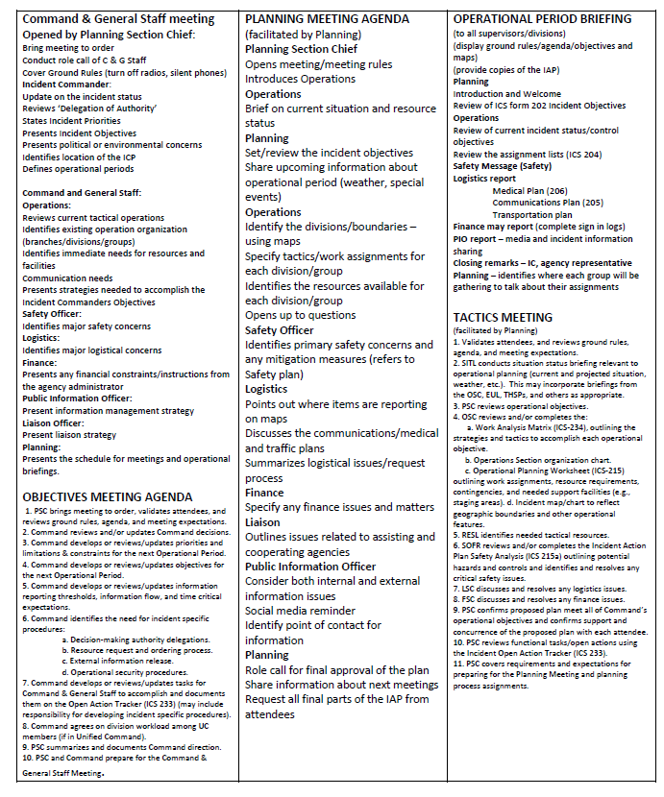
Briefings Guide

ICS Smart Objectives:

All Hazards Objectives
- Provide for the safety of responders and the public/citizens for the duration of the incident.
- Provide for responder safety through the adherence to agency policies and SOP’s during incident operations.
- Evaluate safety concerns for incident personnel and public thru utilization of risk management principles.
- Ensure proper PPE is worn and appropriate safety procedures are followed at all times.
- Evacuate all residents between _____ and _____ streets by _____hours.
- Facilitate orderly evacuation of the affected area/scene/endangered persons.
- Continue to evaluate the effectiveness of the evacuation boundary.
- Construct sandbag diversion away from ___ by ___ hours.
- Monitor activities and respond to maintain peace, order and life safety.
- Maintain a functional emergency response system.
- Return all public facilities used for the response to at least minimal operational condition within ___ hours.
- Maintain/Provide/Establish normal public safety operations/services
- Provide for immediate and on-going life, health, and safety needs.
- Return all public facilities used for the response to at least minimal operational conditions by ___ hours
- Maintain facility isolation
- Access and document damagers of the impacted areas
- Complete a damage survey within 12/24 or ___ hours
- Complete preparations for all aspects of _____ operations
- Continue reconnaissance at ______ by ___hours
- Create appropriate documentation to support response (S & R) efforts
- Continue on-site assessment of critical infrastructure
- Complete an “areas of risk” assessment/size up.
- Continue to coordinate operations between agencies
- Manage a coordinated response effort
- Provide and control support to the incident/event command
- Keep costs commensurate with values at risk
- Utilize best practices relative to cost and time management
- Ensure a positive work environment for all personnel
- Maintain high visibility throughout the community
- Support the physical needs of staff and rescue workers
- Evaluate requests for assistance as received from external entities
- Protect private property, improvements and other commercial endeavors
- Maximize/continue/monitor protection of environmentally sensitive areas
- Minimize economic impact of the affected area/community
- Provide resource support for the community
- Continue volunteer management efforts
- Provide ‘just in time’ training for responders that arrive to assist
- Assure basic needs services of affected residents
- Communicate with Unified Command to ensure compliance with _____
- Keep stakeholders, responders and public informed of response activities
- Provide the ability to interface with media
- Ensure an effective communications system is established
- Maintain communications within the incident at all times
- Ensure interoperability of communications
- Establish communication protocols with public safety, municipalities, schools, general public, medical facilities
- Foster communications between ___ and ___
- Establish means to educate the public and responders
- Keep the public informed on the status of the incident
- Continue information exchange with media, active personnel and incident command
- Provide for the media information management to the public, responders and family members
- Provide accurate and timely information to the public, stakeholders, and cooperating agencies
- Continue to issue emergency public service information concerning the situation
- Establish a joint information system center
- Maximize protection of environmentally sensitive areas
- Begin the recovery mission/operations
- Continue personnel and asset tracking
- Utilize unified command structure
- Project an approximate and appropriate number of patients/injuries/causalities
- Activate and maintain critical stress management team
- Establish a reunification center/point for affected persons
- Establish a welcome center by ____ hours
- Continue mass care and sheltering
- Establish severe weather shelter(s)
- Reduce resources as necessary to meet the needs of the incident
- Monitor weather conditions of the present operational period
- Provide necessary transportation by ____ hours
- Continue academic support for students/staff/responders

Law Enforcement
- Establish perimeter control/establish secure site perimeter
- Isolate terrorists to ____ area by ___ hours
- Establish an isolation zone to evacuate hostages/casualties/victims to immediately
- Immediately stop movement into and out of the facility
- Continue/establish traffic control/pattern
- Provide access control
- Establish safe ingress and egress patterns for all vehicle/pedestrian traffic
- Establish investigative efforts/initiate field investigations
- Prevent any further threat to the public
- Isolate and eliminate active threat
- Preserve crime scene for investigation
- Maintain confidentiality of all sensitive data
- Establish appropriate intelligence functions and intelligence fusion
- Coordinate information with law enforcement authorities
- Provide protection for increased gang activity

Coroner
- Provide mortuary services
- Establish the ability to interface with the coroners office
- Manage incident casualties

Fire/EMS/HazMat
- Provide hazardous materials mitigation to include decontamination
- Identify all hazardous materials carried on the ______
- Mitigate life safety/environmental hazards caused by leaking hazardous materials
- Conduct hazmat operations in accordance with the site safety plan
- Identify current and potential hazardous materials releases with potential impacts to the public and environment including human exposure, municipal water supplies, air quality, etc…..
- Establish HAZMAT clean up activities with a target completion time of ____ hours
- Continuously monitor waterways/air quality for possible contamination from hazardous materials
- Provide the community with fire and emergency services
- Establish emergency medical services to the impacted areas
- Provide care for the injured
- Continue fire suppression efforts in effected area
- Protect private property, other improvements and identified areas of risk by utilizing the appropriate firefighting strategies
- Apply recognized firefighting tactics and principles to control the fire area
- Keep abreast of changing fire conditions
- Provide support for fire suppression activities
- Continue search and rescue efforts/operations
- Initiate fire investigation efforts
- Utilize best practices for smoke management

Public Works
- Establish debris removal efforts in the affected areas
- Maintain all routine public works services
- Coordinate public utility service issues (gas, electric, water)
- Secure all utilities before ____ hours to prevent gas leakage and electrical shock

Public Health
- Continue public health efforts/special need services
- Maintain facility isolation
- Depopulate then dispose of ____ at entire facility
- Implement rapid testing for _____ on humans
- Establish temporary testing site near facility
- Establish biosecurity measures on site
- Establish the ability to identify the source of a public health outbreak
- Continue to define the scope of the outbreak
- Provide the ability to process and analyze pertinent information about the evolving disease outbreak
- Continue surveillance of medical needs
- Continue surveillance of efforts of the outbreak
- Characterize the organism including antibiotics resistance
- Implement mass fatality plan
- Initiate investigation efforts/establish field investigations with law enforcement
- Continue investigative efforts to identify source of outbreak
- Continue to coordinate public health activities between agencies and partners
- Fulfill SNS mission
- Ensure adequate medical supplies are available

Wildlife Maintenance Objectives
- Continue detoxification operations
- Continue sentinel organism monitoring of chemical operations
- Communicate with unified command members to ensure compliance with waterway security and maintenance
- Complete preparations for all aspects of ____ application and detoxification
- Protect threatened, endangered and sensitive species
- Recover and rehabilitate injured wildlife

Training objectives
- Provide for the safety of students, staff, the general public and infrastructure
- Ensure the safe conduct of training with the greatest amount of participation possible
- Establish a safe and learning conducive environment for students
- Provide an environment that facilitates student learning
- Provide comprehensive instruction regarding _____
- Provide a forum for interaction between those responsible for ______
- Assist in the development of profession credentials for those involved in the field of ____
- Teach the highest standards of profession ethics
- Complete all instructional objectives
- Return all facilities to the previous state of readiness
- Complete all course related documentation incompliance with the class check list
- Represent the ____ agency in a professional manner, both on and off site
- Assist the ____ in the planning and operation of the ____ event
- Develop assignment lists for the instruction staff that give them proper guidance for conducting their training
- Strength the relationship between ____ and ____
- Contain fire to the designated training area
- Protect identified areas of risk within the training area

