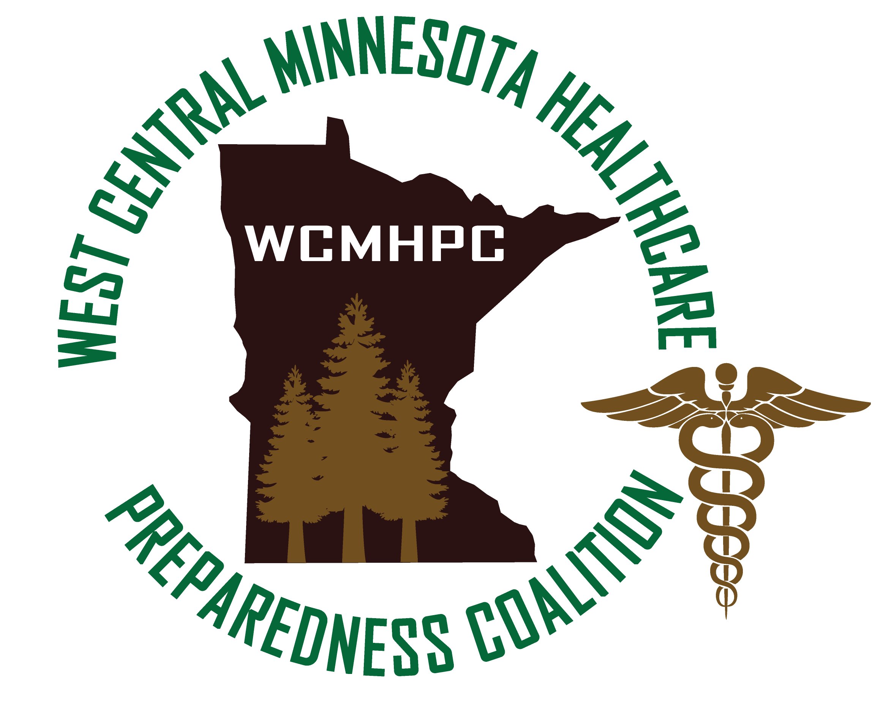
Agenda
West Central Minnesota
Healthcare Preparedness Program
5 March 2020

Advisory Committee Meeting 1000 – 1100

1000 - 1100 Advisory committee
- Financial Report
  - Reminders to continue to track in-kind EP expenses (including any special purchases related to COVID 19
- Ebola Disbursement
  - All hospitals should have received their disbursement checks – if you have not received them yet please let me know so we can track the funds.
  - Waiting on an invoice from WCEMS to finalize and close out the Ebola budget. Yesterday the equipment purchased was disbursed to the EMS service managers. This equipment will be shared with local first responders to assist in cleaning rigs.
  - We did expend all the funds.
- Future projects:
  - Dave is working extensively on the August training and exercise
    - Located at Camp Ripley
    - Training day one building up to the full day of exercise
    - Central region contracted with All Clear
    - Date is August 18th and 19th
    - Cost for participants in WC has not been figured out but it will be nominal (thinking $50 per person) – just to cover the cost of the lodging
  - MYTEP is due the end of March – I am still working on it
  - Workplan meeting is scheduled for Tuesday, March 10th at 1 p.m. – we do appreciate all that have signed up to listen/participate. Your input is extremely valuable during this process. If you have not received the calendar invite and are available to participate please let Shawn know.
  - Out with one – in with another? With the announcement that the Federal Government is allocating 8.2 billion dollars to COVID 19 – there is the potential that we will be receiving funds at the coalition level. If this occurs then we will convene an extra meeting with the advisory committee to discuss how we are going to utilize the funds.
    - i.e. Buddy System reimbursement
    - LTC training/support
    - EMS training/support
  - Buddy system – how can hospitals support their local partners in a COVID response – keep conversation short and discuss further in the breakouts
    - Support LTC and EMS by providing Fit Testing support, N95 respirator sharing/gown sharing ect. (track expenses/log the support)

All Coalition Meeting 1100 – 1500

1100 – 1215 COVID 19 update/Pandemic Planning ALL
Group broke up per county and discussed Covid planning

1215 - 1245 Lunch

1245 - 1400 Alternate Care site workshop ALL
- This is really to bring each county together to discuss planning efforts – you are all in charge and control the direction of your conversations. We will periodically check in….and have each table report out on the results.
- There are a lot of slides/questions – we may or may not get through them all – it will be up to you all how long we work on this
- Do we want to do more frequent meetings/face to face? To work through this? Do we do this as a region or as a county? We do need to invite our local EMS and LTC/assisted living partners. I am more than willing to come out to each county to facilitate the discussions.

