Respiratory Protection Program

&

Template

Clinics, Hospitals and Long Term Care

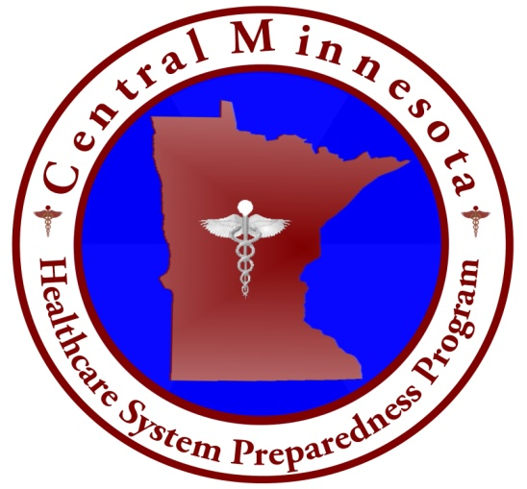 

*This template is provided by the Central and West Central Minnesota Healthcare System Preparedness Program for public use and is not protected by copyright. You have permission to edit and use this template as a resource in developing a written Respiratory Protection Program for your facility. June 2013*

**Instructions**

This Respiratory Protection Program was prepared and intended to be used as a template for medical clinics, hospitals and long term care facilities. You are encouraged to use this guide to develop a respiratory protection plan that meets the specific needs of your organization. The samples contained in this template are not meant to represent accepted standards of practice, but are examples of procedures that clinics, hospitals and long term care may want to consider. Use of this program and templates does not guarantee compliance with Minnesota OSHA standards, but is meant to help your organization fulfill the requirements for a written respiratory protection program as one of the components of a comprehensive program to protect employees. It is up to each facility’s administration to comply with this standard and important you’re your administrators reference the OSHA Respiratory Protection Standard *1910.134* for details on specific requirements. It is up to each facility’s administration to comply with this standard.

The templates included within this program are designed to be flexible and have been made available in an editable Microsoft Word document format. Each facility can customize to meet their specific needs and there are places throughout the document where you will need to fill in a blank or change a generic placeholder (such as ABC Hospital) to customize it to your facility. The italicized text gives you instructions, tips or ideas for customizing sections that you may want to change. Lastly, make sure that when customizing this template, you include each section that is in the template since each of these components are required by the OSHA standard.